- Copyright for test papers and marking guides remains with West Australian Test Papers.
- The papers may only be reproduced within the purchasing school according to the advertised conditions of sale.
- Test papers must be withdrawn after use and stored securely in the school until Wednesday 19th October 2011.


PHYSICS

YEAR 12

STAGE 3

2011

Name: _______________________________________________________

Teacher: ___________________________________________________

TIME ALLOWED FOR THIS PAPER

Reading time before commencing work: Ten minutes
Working time for the paper: Three hours

MATERIALS REQUIRED/RECOMMENDED FOR THIS PAPER

To be provided by the supervisor:
- This Question/Answer Booklet; Formula and Constants sheet

To be provided by the candidate:
- Standard items: pens, pencils, eraser or correction fluid, ruler, highlighter.

- Special items: Calculators satisfying the conditions set by the Curriculum Council for this subject.

IMPORTANT NOTE TO CANDIDATES
No other items may be taken into the examination room. It is your responsibility to ensure that you do not have any unauthorised notes or other items of a non-personal nature in the examination room. If you have any unauthorised material with you, hand it to the supervisor before reading any further.

Structure of this paper

Section | Number of questions available | Number of questions to be answered | Suggested working time  (minutes) | Marks available | Percentage of exam
Section One:  Short answer | 13 | 13 | 50 | 54 | 30
Section Two:  Extended answer | 8 | 8 | 90 | 90 | 50
Section Three:  Comprehension  and data analysis | 2 | 2 | 40 | 36 | 20
 |  |  | Total | 180 | 100

Instructions to candidates

1. The rules for the conduct of Western Australian external examinations are detailed in the Year 12 Information Handbook 2010. Sitting this examination implies that you agree to abide by these rules.

2. Write answers in this Question/Answer Booklet.

3. You must be careful to confine your responses to the specific questions asked and follow any instructions that are specific to a particular question.

- Working or reasoning should be clearly shown when calculating or estimating answers. It is suggested that answers to calculations are given to 3 significant figures except when you are required to estimate. For estimation questions an appropriate number of significant figures must be stated.

5. Spare pages are included at the end of this booklet. They can be used for planning your responses and/or as additional space if required to continue an answer.
  - Planning: If you use the spare pages for planning, indicate this clearly.
  - Continuing an answer: If you need to use the space to continue an answer, indicate in the original answer space where the answer is continued, i.e. give the page number. Refer to the question(s) where you are continuing your work.

Section One: Short response 30% (54 Marks)

This section has 13 questions. Answer all questions. Write your answers in the space provided. Suggested working time for this section is 50 minutes.

Question 1
A sound wave travels through water to meet a boundary with a solid concrete wall of a dam.
Sound wave
Water
Solid Concrete Wall

- Draw a possible path of the sound wave as it refracts into the concrete. Indicate appropriate angles.
(1)

- The wave fronts in the water are shown on the diagram. Indicate the general pattern of wave fronts when the sound wave travels in the solid concrete wall.
(1)

- Is it possible for total internal reflection to occur at this boundary? Explain briefly.
(1)

Question 2
NS
N

S
Compass
Two identical magnets are fixed in position on a flat bench. A compass is placed near the magnets.

- Sketch the magnetic field in the region around the magnets. Draw at least 4 field lines for each magnet.

(2)

- Indicate the direction that the compass needle will point by placing an arrow in the circle.
(1)
Question 3
By banking the curves of racetracks it is possible for vehicles to turn in a horizontal circle without relying on friction. For a car of mass 1 700 kg the angle of banking is set at 13.4° above the horizontal. The curve has a radius of 171 m and the car drives at a speed to maintain its height.
Vector diagram

13.4°

- Draw a vector diagram showing the forces acting on the car and the sum of those forces in the space indicated above.
(1)
- Calculate the centripetal force acting on the car.
(3)

Question 4
Aluminium-29 decays to Silicon-29 by beta emission as described in the nuclear equation:
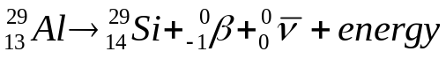
  - Identify the particle with the symbol 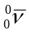
(1)

  - The beta particle is an electron that has come from the nucleus. Explain how the beta particle and the particle appeared. [Useful information is as follows: The quark composition of a proton = up + up + down, the quark composition of a neutron = up + down +down.]
(3)

Question 5
An iron ball of mass 220 kg is suspended from the end of a rigid steel girder.
Steel wire
Pivot point
1.60 m
50º
Girder mass 180 kg
Rigid upright
Iron ball
mass 220 kg
65º
Diagram is not drawn to scale.

The girder has a mass of 180 kg and a length of 2.40 m.

The girder is pivoted to a rigid upright.

A steel wire is attached 1.60 m along the girder. It holds it in equilibrium with angles between components as shown in the diagram.

- Identify all the forces acting on the girder by drawing them on the diagram.
(1)

- Demonstrate by calculation that the tension in the steel wire is 5.39 × 10³ N.
(3)

Question 6
Refer to the diagram and description in Question 5. If the tension in the steel wire is 5.39 × 10³ N calculate the magnitude and direction of the reaction force from the pivot acting on the steel girder.
(4)

Question 7
A 70 kg skier is on a frictionless slope. He follows a circular path of radius 11.0 m as he goes over a mound and has a speed of 7.60 m s⁻¹ at the top of the circle.
Radius 11.0 m
Skier 7.60 m s⁻¹

Calculate the normal reaction force he experiences from the mound at the top of the circle.

(4)

Question 8
A jet airliner is flying due South in the Northern geographical hemisphere where the Earth’s magnetic field has a flux density of 5.20 × 10⁻⁵ T at an angle of dip of 54°

- Sketch the alignment of the Earth’s magnetic field lines relative to the jet airliner on the diagram, indicating any angles and direction.
(2)

- Calculate the emf induced across the 60.0 metre wingspan if the jet has a speed of 140 m s⁻¹.

(3)

- Circle the best response. There would be a build-up of electrons at the:
(1)
A. West wing tip B. East wing tip C. Middle of the wings
Question 9
An astronaut flies past a stationary observer at a constant 85% of the speed of light. His spacecraft has light A at the front and light B at the rear. The stationary observer sees the two lights A and B illuminate simultaneously. The astronaut sees one light illuminate before the other one.
0.85 c
Light B
Light A
Stationery observer
Astronaut

- From the frame of reference of the astronaut explain the order of the lights going on.
(2)

- The astronaut and the observer both have identical stopwatches set to countdown from one minute. As the astronaut passes the observer both stopwatches commence their countdown. The astronaut states that his stopwatch will finish the countdown first but the observer states the opposite. Explain who is correct and why.
(2)

- The stationary observer has previously seen the spacecraft from the same distance when it was at rest. He remarks that it seems smaller when it flies past him at 85% the speed of light. Explain in which way the spacecraft seems smaller and also in which way it has retained the same dimensions.
(2)

Question 10
A charged particle enters a region between 2 parallel charged plates. The plates are separated by 4.00 cm. The electric field strength in the region between the charged plates is 8.75 × 10⁴ V m⁻¹.
Negative plate
Positive plate
Charged Particle
4.00 cm
- Calculate the potential difference between the plates.
(2)

- The charged particle experiences a force of magnitude 2.80 ×10⁻¹⁴ N that causes it to deflect towards the negative plate. Determine the magnitude and nature of the charge of the particle.

(3)

Wavelength × 10⁻¹¹ m
Intensity
(Photon count)
Question 11
The graph shows the X-ray spectrum from a target metal bombarded by electrons with a supply voltage of 33.0 kV

- Show on the X-ray spectrum diagram the line emission portion of the spectrum and explain briefly how it is formed.

(3)

- Sketch on the graph, the general shape of the X-ray spectrum if the supply voltage is decreased to 31.0 kV. (2)
Question 12

Quark | Charge
Up (u) | 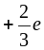
Down (d) | 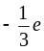
Charmed (c)
Strange (s)
Top (t)
Bottom (b)
Hadron | Quarks
Proton | 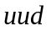
Neutron | 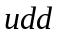
Kaon-minus | 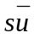
Pi-plus (π⁺) | 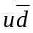
Sigma-plus
Lambda-zero | 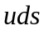
Charmed Omega

- Determine the charge (coulombs) of the Lambda-zero: ___________________________
(1)

- Determine the charge (coulombs) of the Kaon-minus: ___________________________
(1)

- Briefly explain why quarks of like charge are not repelled from each other in a hadron.
(2)

Question 13
A source of sound waves can be directed through air at 25ºC towards an 8.65 cm gap between two wooden blocks. The wave source can emit either

- Sound waves at a frequency of 5.0 kHz, or
- Sound waves at a frequency of 500 Hz

Explain briefly which wave will diffract more and why.
(2)

End of Section One
Section Two: Problem-solving 50% (90 Marks)

This section has eight (8) questions. You must answer all questions. Write your answers in the space provided. Suggested working time for this section is 90 minutes.

Question 14 (13 marks)

A satellite is in orbit around the equator of the Earth. It has a mass of 1495 kg and is at an altitude of 1.91 × 10⁴ km above the Earth’s surface.

Satellite
View of Earth from above North Pole

- Calculate the period of this satellite and state your answer in hours.
(4)

- Explain whether or not a satellite can be geostationary at this altitude.
(2)

- Place labelled arrow(s) on the diagram to show the direction of the net acceleration of the satellite.
(1)

- Give two examples of the uses of artificial satellites in everyday life.
(2)

The Earth is a natural satellite that orbits the Sun. (Assume a circular orbit for this question)

- Calculate the orbital speed of the Earth as it goes around the Sun.
(3)

- If the Sun was 90% of its current mass, describe how the orbital speed of the Earth would be affected if it remained at the same distance from Sun. (A calculation is not required)
(1)

Question 15 (13 marks)

An eagle has captured a fish and is 14.7 m directly above the water when it releases the fish. The eagle is moving with a velocity of 5.20 m s⁻¹ at an angle of 36.6º above the horizontal when the fish is released. Ignore air resistance for calculations.
36.6°
5.20 m s⁻¹
14.7 m
This diagram is NOT to scale

- Calculate the time taken for the fish to reach the water.
(4)

- Calculate the horizontal distance that the fish travels during its flight back to the water.
(3)

- Calculate the maximum height above the water that the fish reaches during its flight.
(3)

If air resistance is taken into account then the flight path is altered.

- Sketch the altered flight path onto the diagram.
(1)

- Will the time of flight be longer or shorter when air resistance is taken into account? Discuss the factors that affect this.
(2)

Question 16 (12 marks)

A mining company use an electric pump with an operating voltage in the range 1.25 kV-1.50 kV.
There is only a 240 V_{RMS} supply available. A transformer is used to step up the output voltage to 1.50 kV_{RMS}. The secondary winding of the transformer has 2000 turns of wire.

Input
240 V
Output
1.50 kV
Electric Pump (V_{d} = 1.45 kV)
Cables
Transformer

- Calculate the number of turns required on the primary winding of the transformer.
(2)

The transformer has an electrical power output of 6.45 kW. The underground pump is connected by 1.10 km of cables to the surface. The potential difference across the pump is 1.45 kV.

- Calculate the total resistance of the cables. (4)

- Calculate how much electrical energy per second is transformed to heat in the cables.
(2)

- Describe two design features of a commercial transformer that increase its efficiency.
(2)

- Explain why it is more efficient to transfer electricity to the pump at a high voltage of 1.50 kV rather than 240 V.
(2)

Question 17 (13 marks)

The diagram below shows an AC generator consisting of a rectangular coil with dimensions of
14.0 cm × 21.0 cm, and 800 turns of copper wire. The magnetic flux density between the poles is 9.40 mT. The coil is turned at a uniform rate.
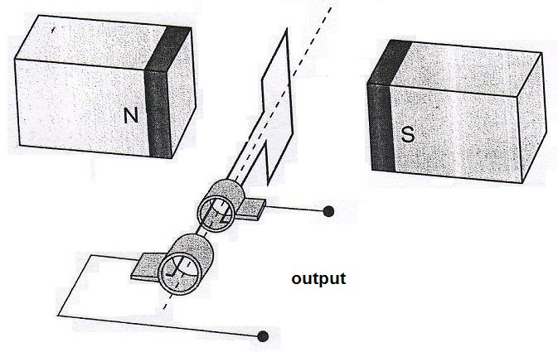
SR
B
B

- Explain the function of the components labelled SR and B.
(2)

- Referring to Lenz’s law, explain how induced emf is achieved from such a generator and why the output is a sine or cosine shape rather than being constant.
(3)

- The coil is rotated at 1500 rpm. Calculate the magnitude of the average induced emf in the coil as it rotates through 90º from the position shown.
(3)

- Sketch the emf output curve for this AC generator on the graph below. You must start from the position shown on the diagram and continue up to 80 ms. Make estimates for values that you cannot calculate.
(3)
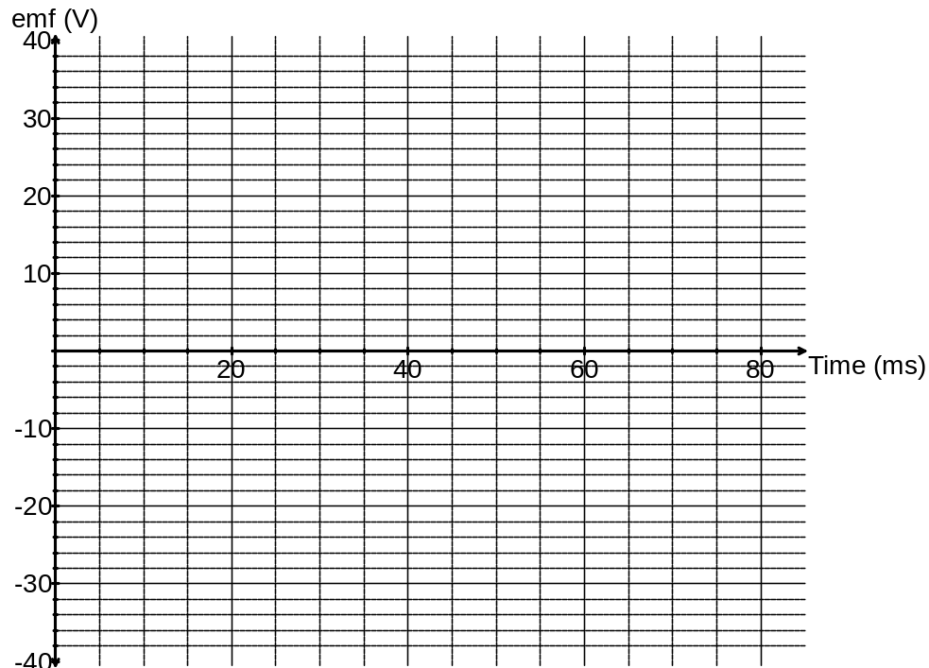

- Identify three times on the graph when the flux enclosed by the coil is a maximum value at 1500 rpm. Circle these times.
(1)

- When the coil is rotated at 750 rpm the emf output changes. Sketch the voltage curve for 750 rpm onto the graph and clearly label it ‘750 rpm’.
(1)

Question 18 (13 marks)

The diagram below details some of the energy levels for a metallic vapour that surrounds a star

0 eV E∞
-0.81 eV E5
-2.20 eV E4

-3.17 eV E3

-5.54 eV E2

-8.92 eV E1 ground state

- Is it possible for this atom to absorb a 6.50 eV photon whilst in the ground state? Explain briefly.
(1)

- Whilst in the ground state the atom absorbs a 6.72 eV photon. How many lines in the emission spectrum would be possible as the atom de-excites? Indicate them on the diagram.
(1)
Number of lines =

- Calculate the longest wavelength possible in the emission spectrum when an atomic electron at E4 can de-excite by one or more steps to ground level.
(3)

- For the wavelength you calculated in part c) state which area of the electromagnetic spectrum this belongs to.
(1)

A single atom in the ground state is bombarded by one electron with a kinetic energy of 6.10 eV.

- Detail in the table below the possible photon energies observable on de-excitation and the possible bombarding electron energies after its interactions with the atom.
(3)

Possible photon energies on de-excitation (eV) | Possible bombarding electron energy after interaction with the atom (eV)

- Explain briefly how analysis of a line absorption spectrum of light from distant galaxies can be used to determine the composition of stars and gas clouds.
(2)

- The line absorption spectrum is also useful to determine the speed of a galaxy. Explain the fundamental principles of this technique.
(2)

Question 19 (13 marks)

A simple musical instrument consists of one steel string held in tension between two moveable bridges. The string is plucked between the bridges so that a musical note is heard. When the sound wave is analysed it can be seen that several frequencies are present at the same time.
Length
Moveable bridge
Tension peg
Moveable bridge

- Explain why several frequencies of sound are present when the single string is plucked.
(2)

- Explain how standing waves can form along the string.
(2)

- The length of the string is set to 30.0 cm and the speed of the transverse waves along the string is 535 m s⁻¹. Calculate the fundamental frequency of the string.
(3)

For a given note played on a musical instrument, the dominant frequency heard is called the fundamental frequency or the first harmonic. The sequence of harmonic frequencies above the fundamental frequency, that are actually present, are known as overtones. So those harmonics above the fundamental are known as the first overtone, the second overtone etc.

- The bridges can be moved and the tension set so that the wave speed along the string stays the same. What length of string is required so that its fundamental frequency is the same as the second overtone of the 30.0 cm string?
(1)

Another simple musical instrument is a pipe, which is an air column closed at one end.

- Sketch the particle displacement wave envelope for the second overtone in the closed pipe.
(2)

- Calculate the frequency of the second overtone in a closed pipe of length 15.0 cm when the air temperature is 25ºC.
(3)

Question 20 (7 marks)

The figure below represents a DC motor whose coil is initially stationary.
- JK = LM = 16.0 cm KL = JM = 12.0 cm
- The coil has 120 turns of wire
- The uniform magnetic flux density between the poles = 95.0 mT
- The current in the coil is 6.30 A when the motor is switched on and it turns clockwise.
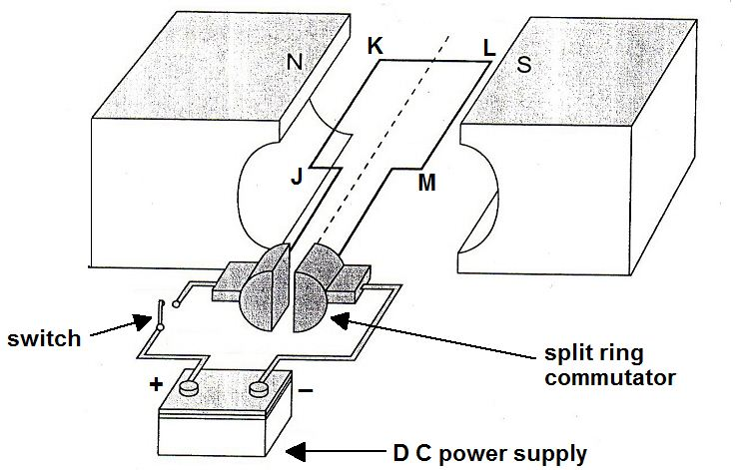
Terminal polarity:
Terminal polarity:
Rotation

- Indicate the positive and negative terminals on the DC power supply for this direction of rotation. (1)

- Calculate the force acting on side LM of the coil when the switch is closed.
(2)

- Calculate the maximum torque that this motor can produce.
(2)

- How much torque will the motor produce when it has rotated 70º from the position shown. Express your answer as a percentage of the maximum torque.
(2)

Question 21 (6 marks)

Alpha particles (He²⁺) are doubly charged positive ions. They are accelerated through an electric field between charged parallel plates before entering a vacuum chamber where they are deflected by a magnetic field.

Alpha particles
Vacuum Chamber
Charged plates
Ion Accelerator
Deflection in magnetic field

- Calculate the potential difference between the charged plates in the Ion Accelerator that will give the alpha particles a maximum velocity of 3.40 × 10⁵ m s⁻¹
(3)

- Indicate on the diagram, the direction of the magnetic field within the vacuum chamber that will cause the deflection shown.
(1)

- The magnetic flux density within the chamber is set to 72.5 mT. Calculate the magnitude of force experienced by an alpha particle travelling at 3.40 × 10⁵ m s⁻¹.
(2)

End of Section 2
Section Three: Comprehension 20% (36 Marks)

This section contains two (2) questions. You must answer both questions. Write your answers in the space provided. Suggested working time for this section is 40 minutes.

Question 22 Hubble’s Law (18 marks)

When a source of waves is moving, a stationary observer notices a change in frequency of the waves. This effect is observed for both longitudinal and transverse waves. For example, if an ambulance moves towards you the sound frequency you hear is higher than the frequency its siren is emitting. This is known as the Doppler Effect.

If a source of electromagnetic waves, such as a star, is travelling away from an observer then the wavelengths of the lines in its electromagnetic spectrum are shifted to higher values. This is called red shift. An equation for the relationship is as follows:
z = red shift
Δλ = change in wavelength (moving source) (nm)
λ = wavelength of stationary source (nm)
v = recessional speed of galaxy (m s⁻¹)
c₀ = speed of light in a vacuum (m s⁻¹)

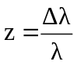 It can also be shown that: 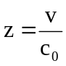

Edwin Hubble analysed the red shifts of various galaxies in 1920 and deduced that most galaxies are moving away from the Earth, this suggests that the Universe is expanding. Hubble also discovered that the further away a galaxy is, the bigger its red shift and the faster it is moving away. This relationship is known as Hubble’s Law and can be stated algebraically as follows:
v_{galaxy} = recessional speed of galaxy (km s⁻¹)
d = distance to galaxy (Mpc)
H₀ = Hubble’s constant (km s⁻¹ Mpc⁻¹)

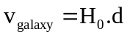

The distances to galaxies can be estimated by observing Cepheid Variables within a galaxy. A Cepheid Variable is a class of star that pulsates. The relationship between the period of pulsation and the size of the star is very precise. An understanding of how brightness diminishes with distance allows astronomers to estimate distances to galaxies with a high degree of confidence.

The following data was recorded by the Hubble Space Telescope for five galaxies.

Distance  (Mpc) | Red shift - z | Recessional speed of galaxy v_{galaxy} (km s⁻¹)
3.1 | 0.00095 | 285
8.6 | 0.00212
12.2 | 0.00273
16.1 | 0.00402
19.4 | 0.00473

- Calculate the appropriate values in the final column of the table (the first value has been done for you)
(2)

- Plot a correctly labelled graph of recessional speed versus distance to galaxy on the graph paper and draw a line of best fit.
(4)



- Calculate a value for Hubble’s constant, in the correct units, showing how you obtained this value from your graph.
(3)

- State three reasons why you think that measurements of Hubble’s constant have varied widely since Hubble’s first determination in 1920.
(3)

- Why does the value of red shift z, have no units?
(1)

- A line in the spectrum of ionised calcium has a wavelength of 393.3 nm when measured in the laboratory. When similar light from the galaxy NGC 3350 is measured, its wavelength is 394.64 nm. Use the red shift formulae to determine the recessional speed of this galaxy.
(2)

- For the recessional speed you calculated in part f), use your graph and the line of best fit to determine the distance to this galaxy in Mpc.
(1)

- Determine how many years it takes for light from galaxy NGC 3350 to reach Earth.
(1 parsec = 3.26 ly)
(2)

Additional working space and spare graph paper

Question 23 (18 marks)
Particle Physics – basic principles and techniques

Particle physics is the modern version of the age old quest – to find the smallest particles that cannot be broken down. Particle accelerators are the ‘laboratory equipment’ in this area of study. Charged particles can be accelerated in two senses – by their change of direction in circular paths or by increasing their speed. Studies can be made on the radiation that they emit whilst being accelerated or the after effects of collisions between high speed particles.

The cyclotron first came into use in 1928 using a combination of magnetic and electric fields to accelerate particles in a spiral path. Development of this technology led to the synchrotron which uses an evacuated circular tube with many magnets placed around its circumference. As particles are accelerated the electric field is adjusted and the strength of the magnets is increased to maintain a constant radius and compensate for relativistic effects that become important at high particle energies.

Any charged particle that accelerates will radiate electromagnetic energy. This is true even at a constant speed in a circular path. So a continual supply of energy is required in synchrotrons to just maintain a constant particle speed let alone increase their speed. The emitted radiation is known as synchrotron radiation and can cover the entire electromagnetic spectrum.

Linear accelerators (LINAC) use a straight path and a series of accelerating voltages as the particles move along the line. LINACs are often used to provide the early stages of acceleration before particles are fed into large synchrotrons.

Collider experiments take two beams of particles that have been separately accelerated in opposite directions and smash them into each other. This is difficult to achieve but if successful it is an efficient use of energy.

When two particles with an equal magnitude of momentum collide head on, the total momentum is zero before and after the collision. If particles are stationary after the collision then their kinetic energy is zero. By the conservation of energy and mass principle, the energy before the collision is transformed into the mass of new particles formed in the collision. The particles that are present after a collision reaction can be different to those that went in. This is exactly what particle physicists aim to achieve and the discovery and study of these new particles underpins their work.

Every collision is governed by one of the fundamental forces (except the force of gravity which has no significant influence on such tiny particles in this context):

- The electromagnetic force leads to simple collisions between charged particles. No new particles are formed when this force is at work. e.g. 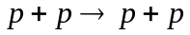
- The strong force dominates reactions between hadrons (which contain quarks). e.g.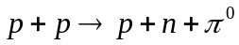
- The weak force is likely to be involved in lepton reactions, especially if one of the leptons is a neutrino. e.g. 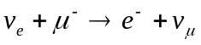
Einstein’s theory of special relativity has led us to the idea that the mass of a moving object is not the same as its rest mass (m₀). The mass of a moving object cannot be measured directly; it must be calculated from a measurement of momentum and velocity. The relativistic equations for momentum p and total energy E are as follows:

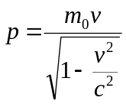 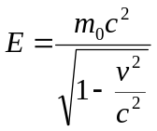 (These equations are only applicable for non-zero mass)

Relativity has also given us the idea of mass-energy equivalence. In Newton’s version of mechanics a lone particle not influenced by gravity or electromagnetism but moving at a given speed could only have a single form of energy – kinetic. At rest it had no energy at all. This is not the case in relativity. The relationship is described by the equation: 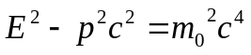

Photons are packets of energy travelling at the speed of light. Surprisingly it has been proved that although photons have zero mass they do have momentum. It can be shown for a photon that
if: then: 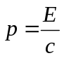 and since 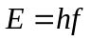 then: 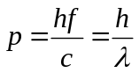

Particle physics has also proven to be vital in understanding the nature of the universe a few fractions of a second after the Big Bang. The conditions created in the mightiest accelerators are very similar to those that existed when the universe was 10⁻¹² seconds old.

Questions

- In what sense can a particle be accelerated if its speed remains constant? Explain.
(2)

- Once a charged particle has been accelerated to a given speed in a circular path, is further energy required to maintain a constant speed? Explain.
(2)

- Can electrons and neutrinos be subject to the strong force? Explain
(2)

- If neutrinos are involved in a collision reaction why is it unlikely that this was governed by the electromagnetic force?
(1)

- If you hit a ping pong ball with a table tennis bat which of the three fundamental forces described governs this collision? Justify your answer.
(2)

- Calculate the momentum of a proton travelling at 95% of the speed of light. The rest mass of a proton is given in the formula and constant sheet.
(3)

- The equation for Einstein’s mass-energy equivalence is:
Show that for a particle at rest this simplifies to E = m₀c²
(2)

- From the starting point: show that the momentum of a photon with zero mass can be given by
(2)

- Calculate the momentum of a photon of 550 nm yellow light.
(2)

End of questions

